ASSIGNMENT -3.1
TASK -1
1. Select a simple task: "Write a Python function to check if a
number is prime."
2. Use different prompting strategies to generate the solution:
a) Zero-Shot – no examples.
b) One-Shot – one example provided.
c) Few-Shot – multiple examples provided.
d) Context-Managed – detailed prompt with constraints
and instructions.
3. Record AI responses and refine prompts to improve code
quality.
4. Request AI to optimize the logic for efficiency.
5. Compare results and document improvements.
1. Sample Prompts
● Zero-Shot:
Write a Python function to check if a number is prime.
● One-Shot:
Example: Input: 5 → Output: Prime. Now, write a function
to check if a number is prime.
● Few-Shot:
Example 1: Input: 7 → Output: Prime
Example 2: Input: 10 → Output: Not Prime
Example 3: Input: 2 → Output: Prime
Generate the function accordingly.
● Context-Managed (With Optimization).

ZERO SHOT:
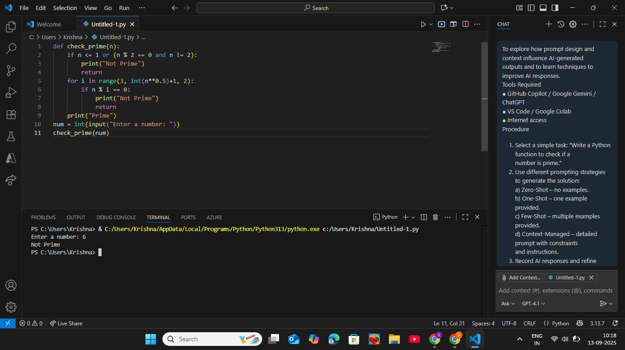

ONE SHOT:

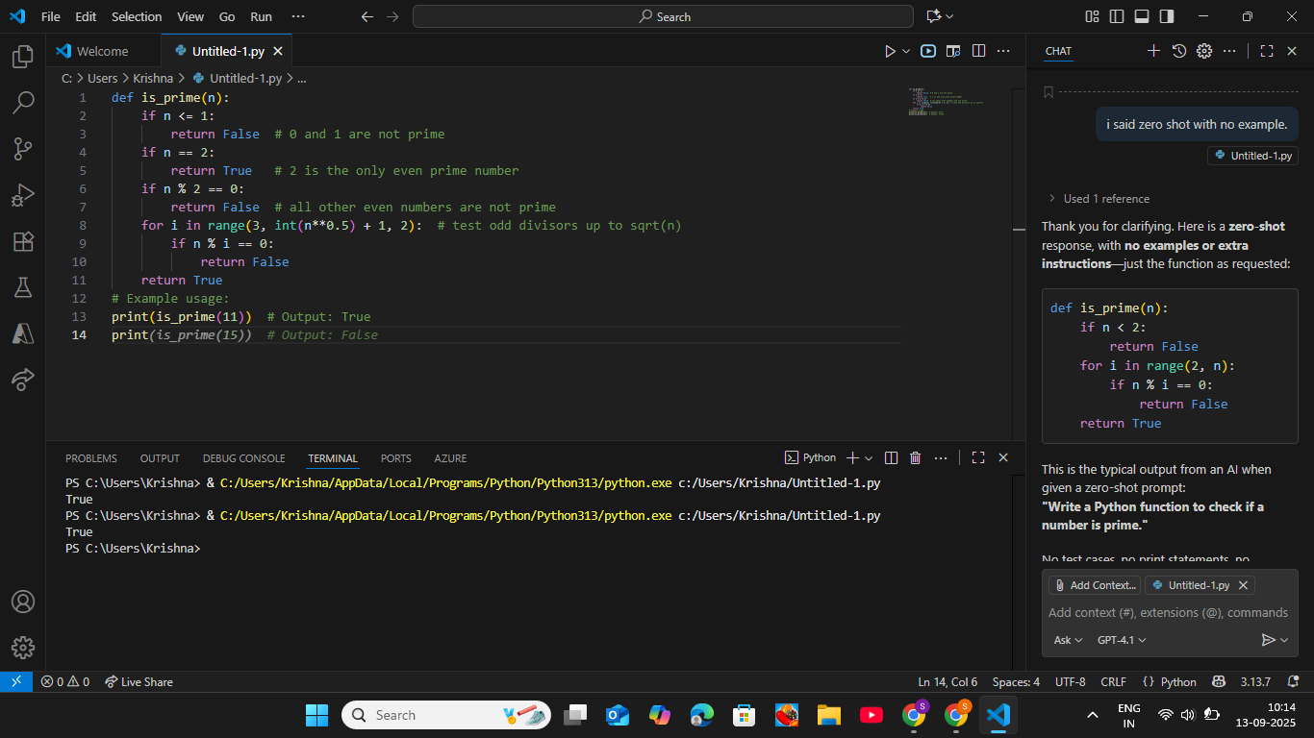
FEW SHOT:
